Multibranch pipeline

* First go to Jenkins manage
* Go to plugins
* Multibranch scam pipeline install

Create multibranch pipeline

1. Click item
2. Enter the item name
3. Click multibranch pipeline
4. Click ok button

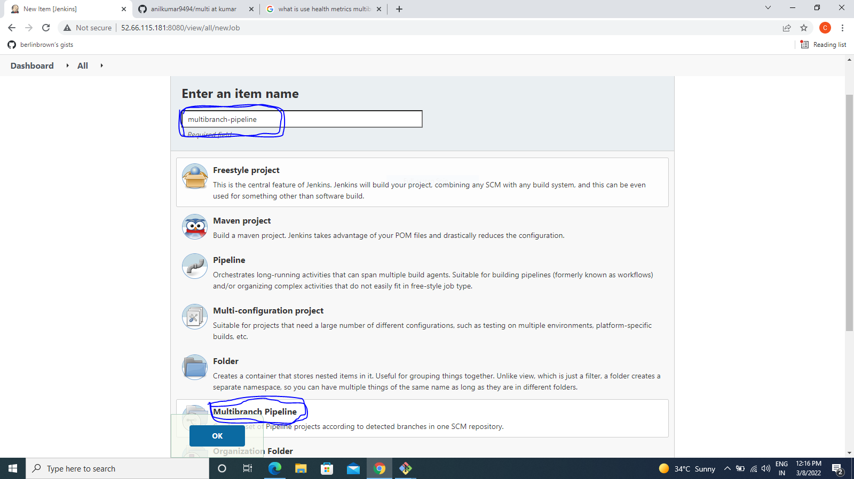

* Display
* Description
* Go to branch sources
* Select github
* Add credtional

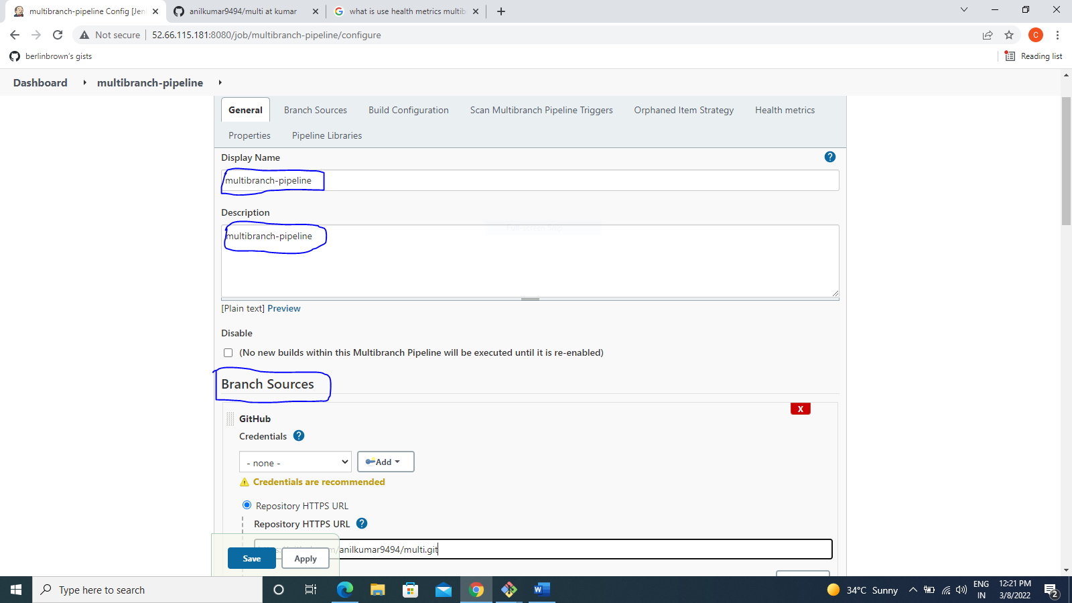

* Your repositories(github your create multi branches repositorie) url copy and paste the jenkines jobs

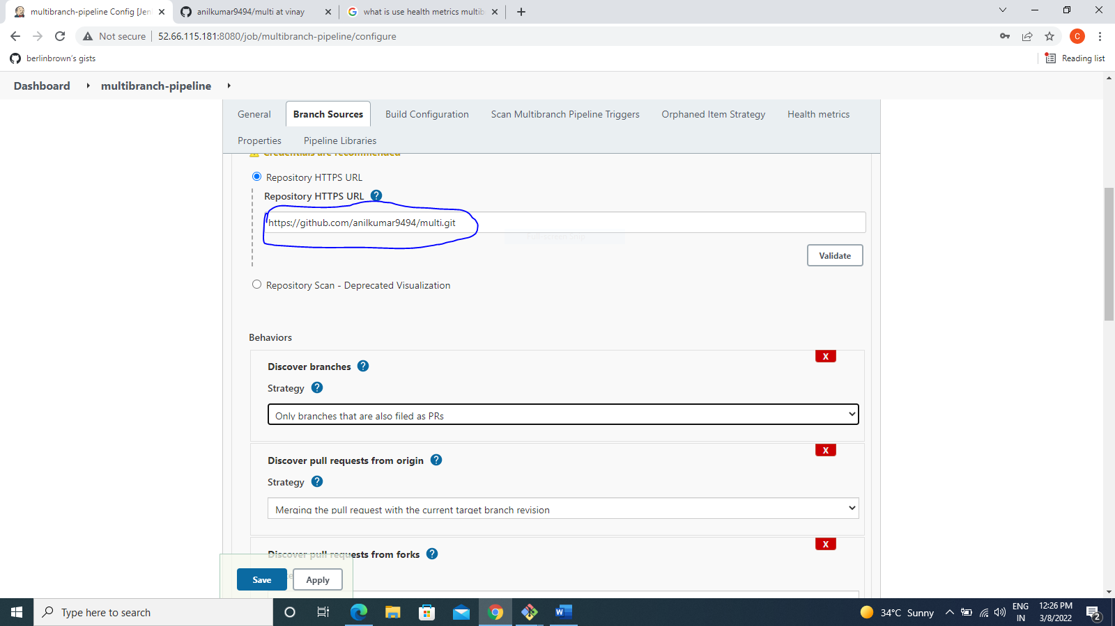

* Your jenkinesfile name
* Scn multibranch pipeline triggers(select scan by webhook)

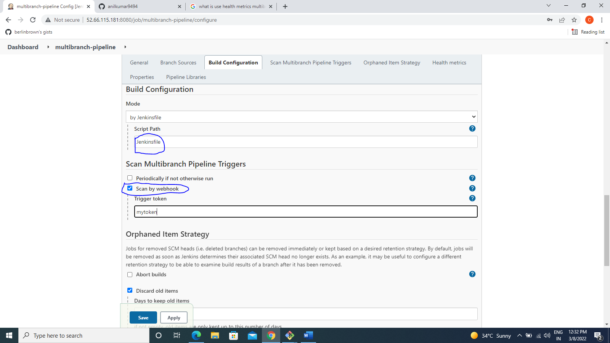

* Click Apply
* Click save

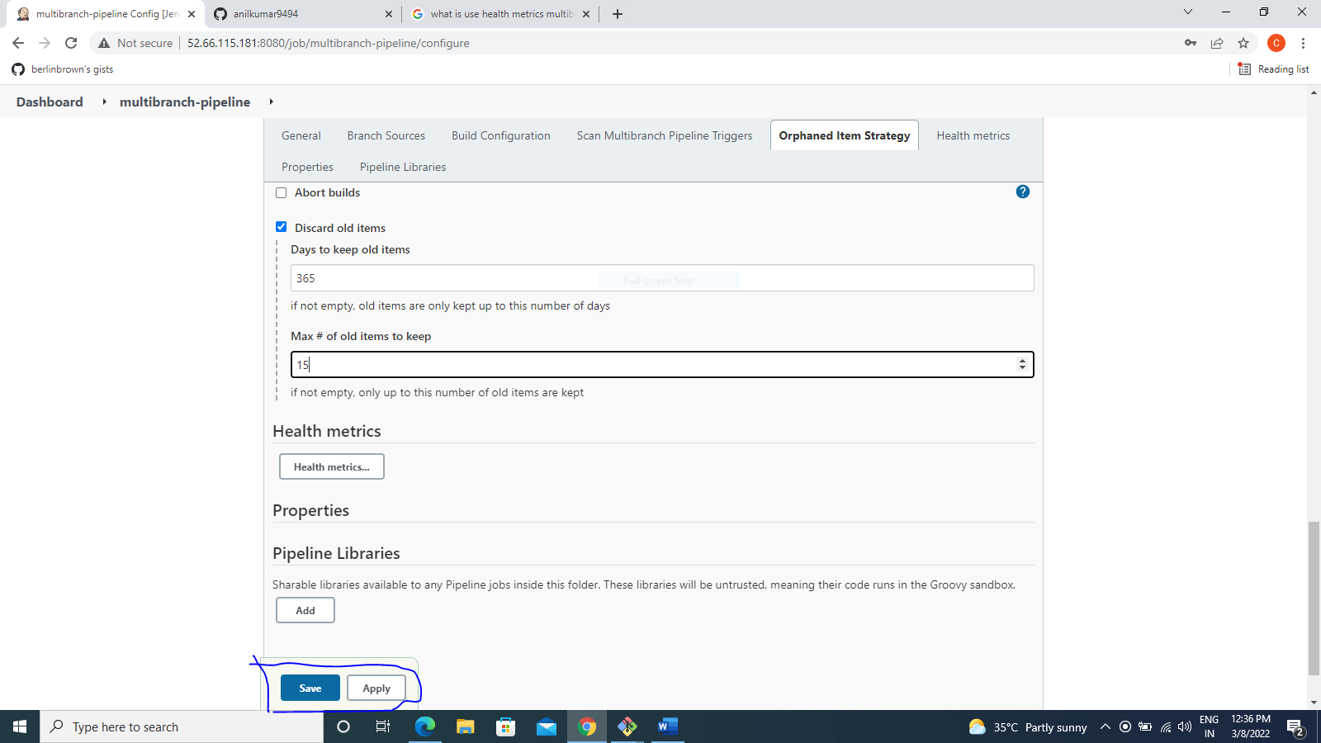

* Go to dashboard
* Click your job multibranch-pipeline

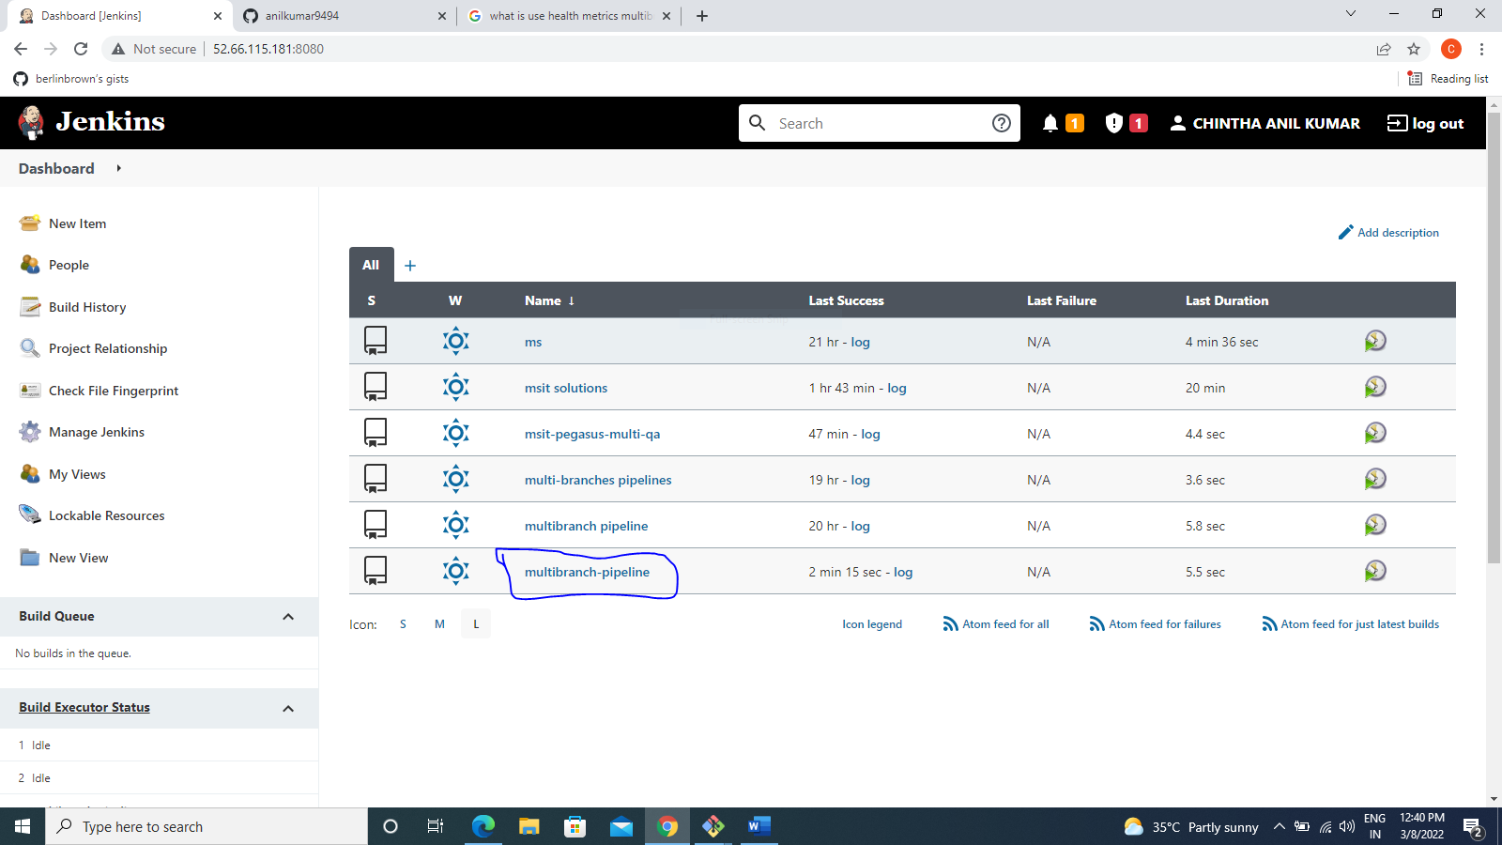

* Your branch,pull requests
* Click branch name

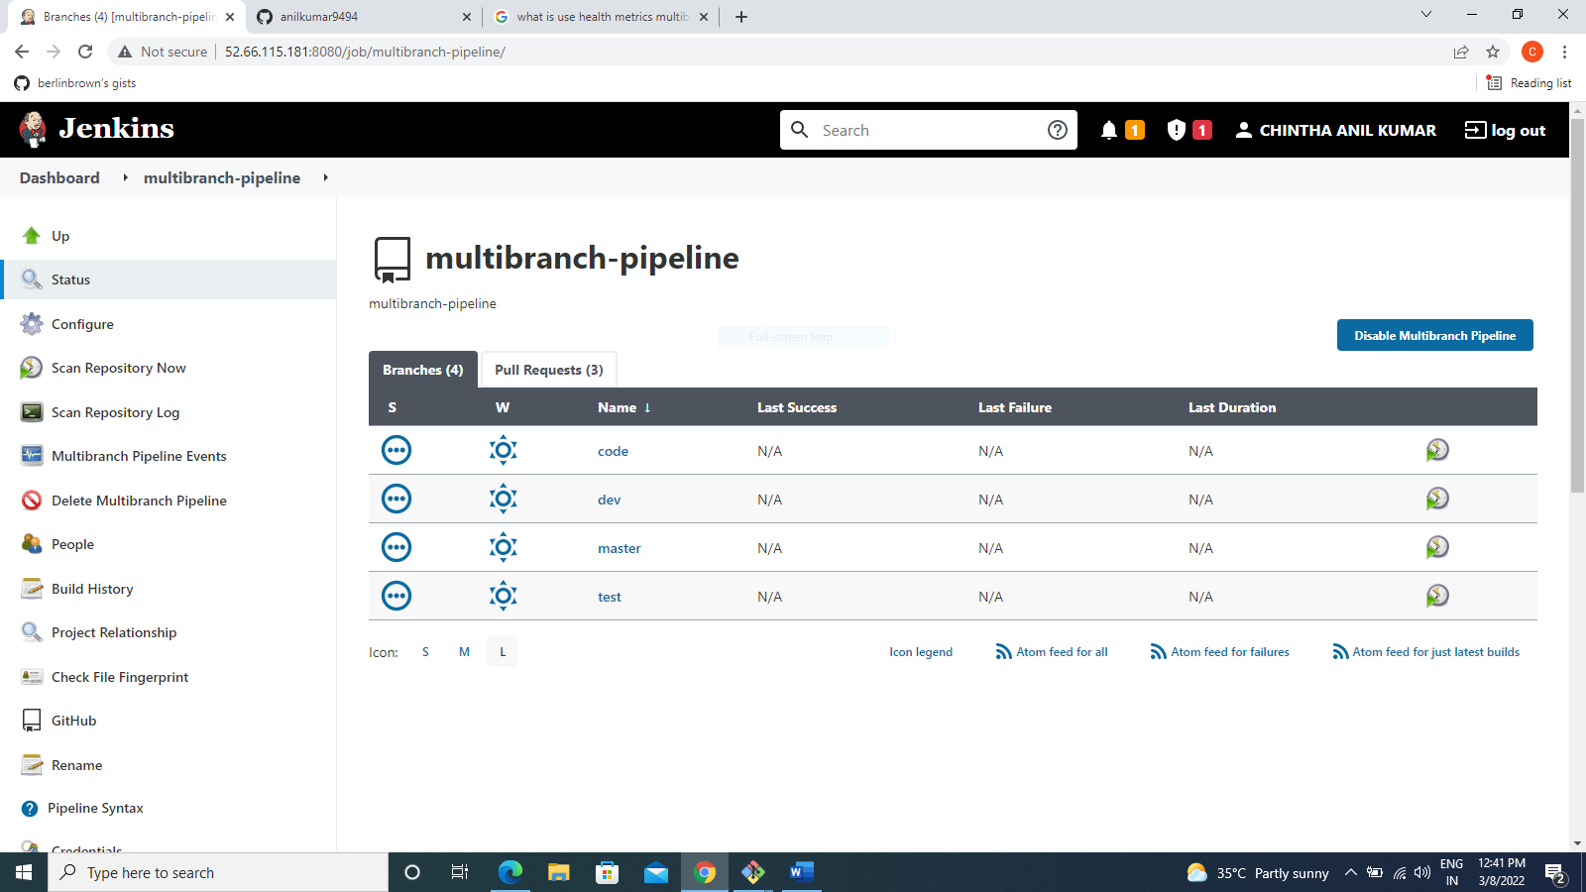

* Show build ,test ,deploy stages

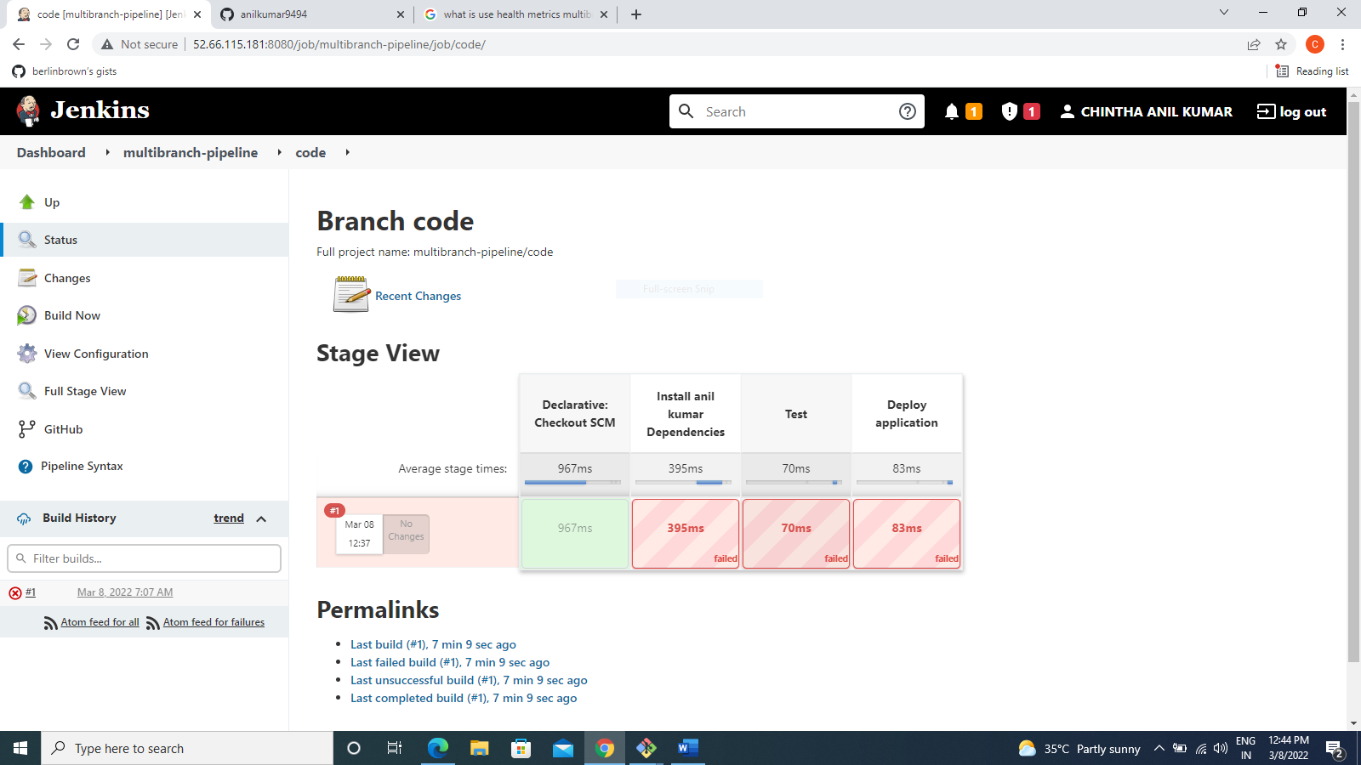

* Click scam repository now

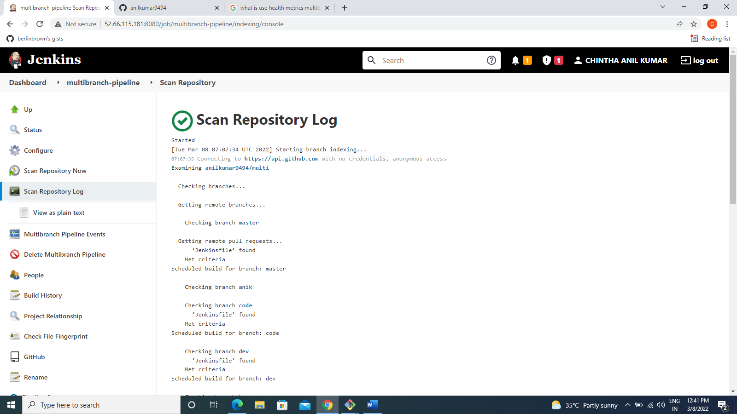

* Go to github your repository

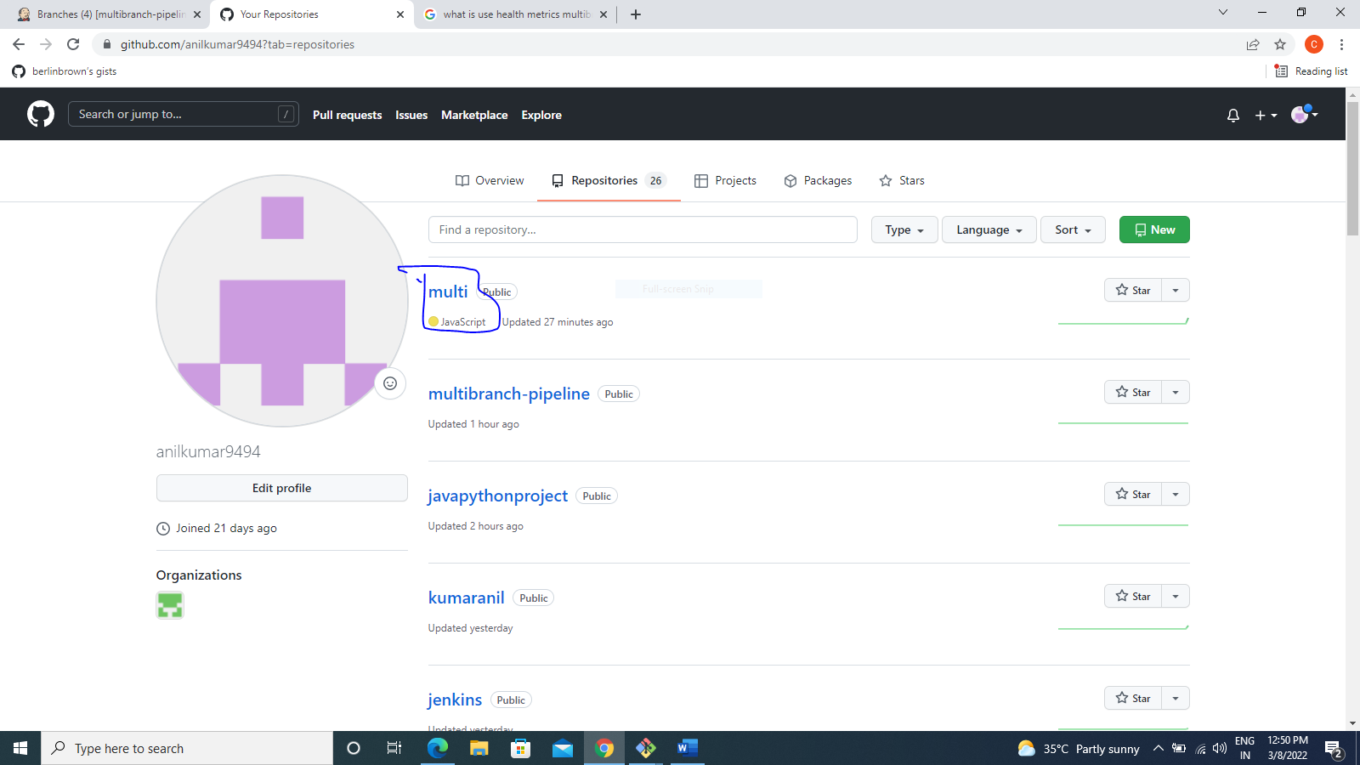

* Click settings
* Click webhook
* 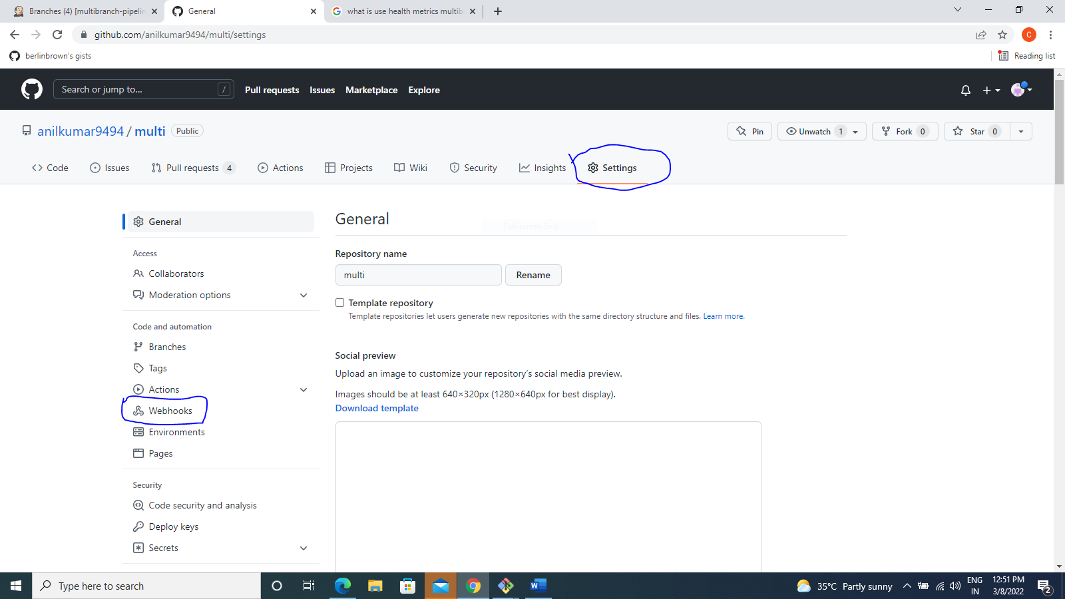
* Click Add webhook

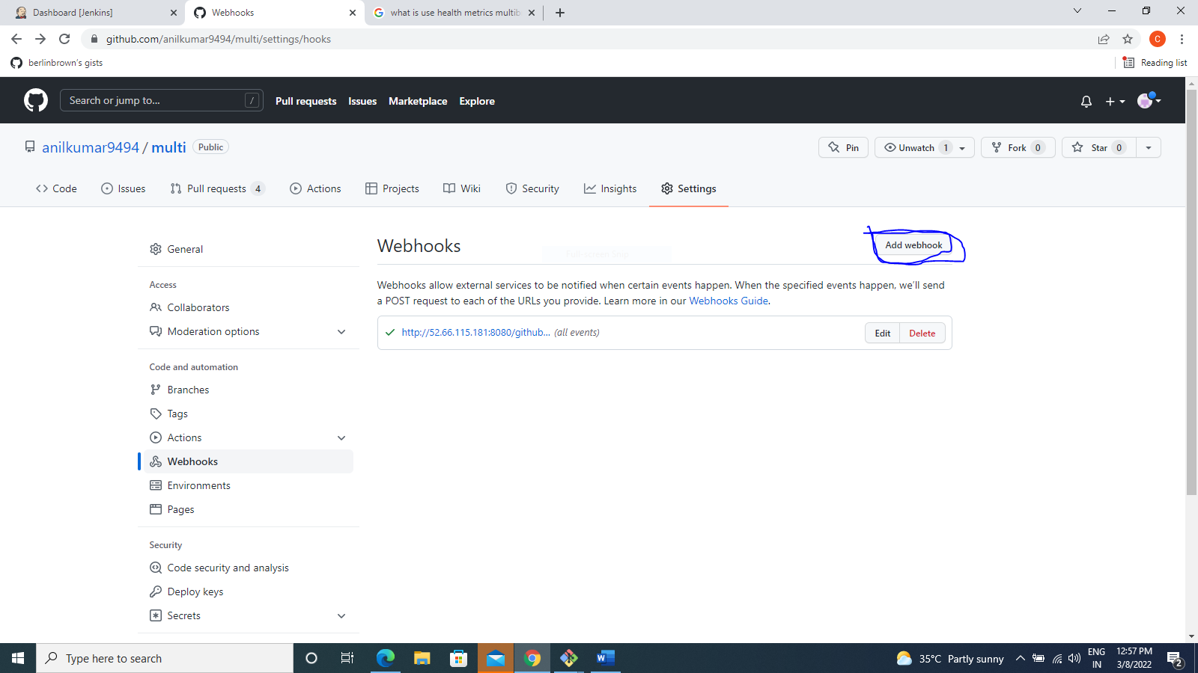

* Go to jenkines copy url ip address Copy

* 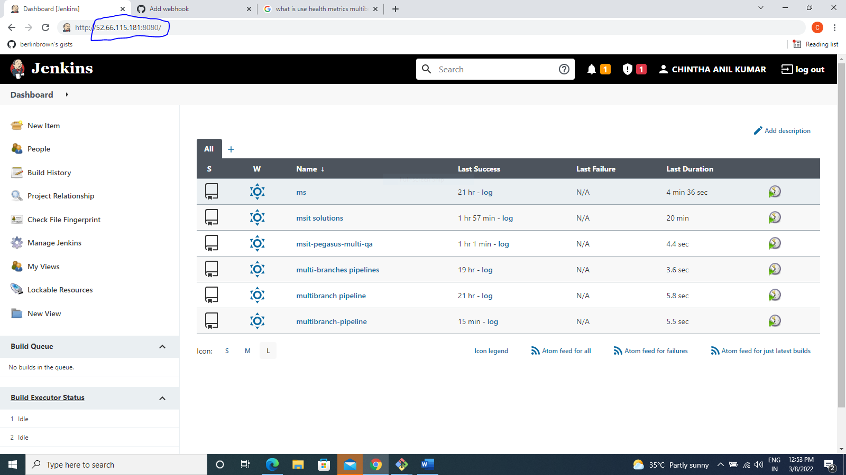
* Paste payload url <http://52.66.115.181:8080/github-webhook/>
* Choose context type
* Select send me everything
* Click Add webhook

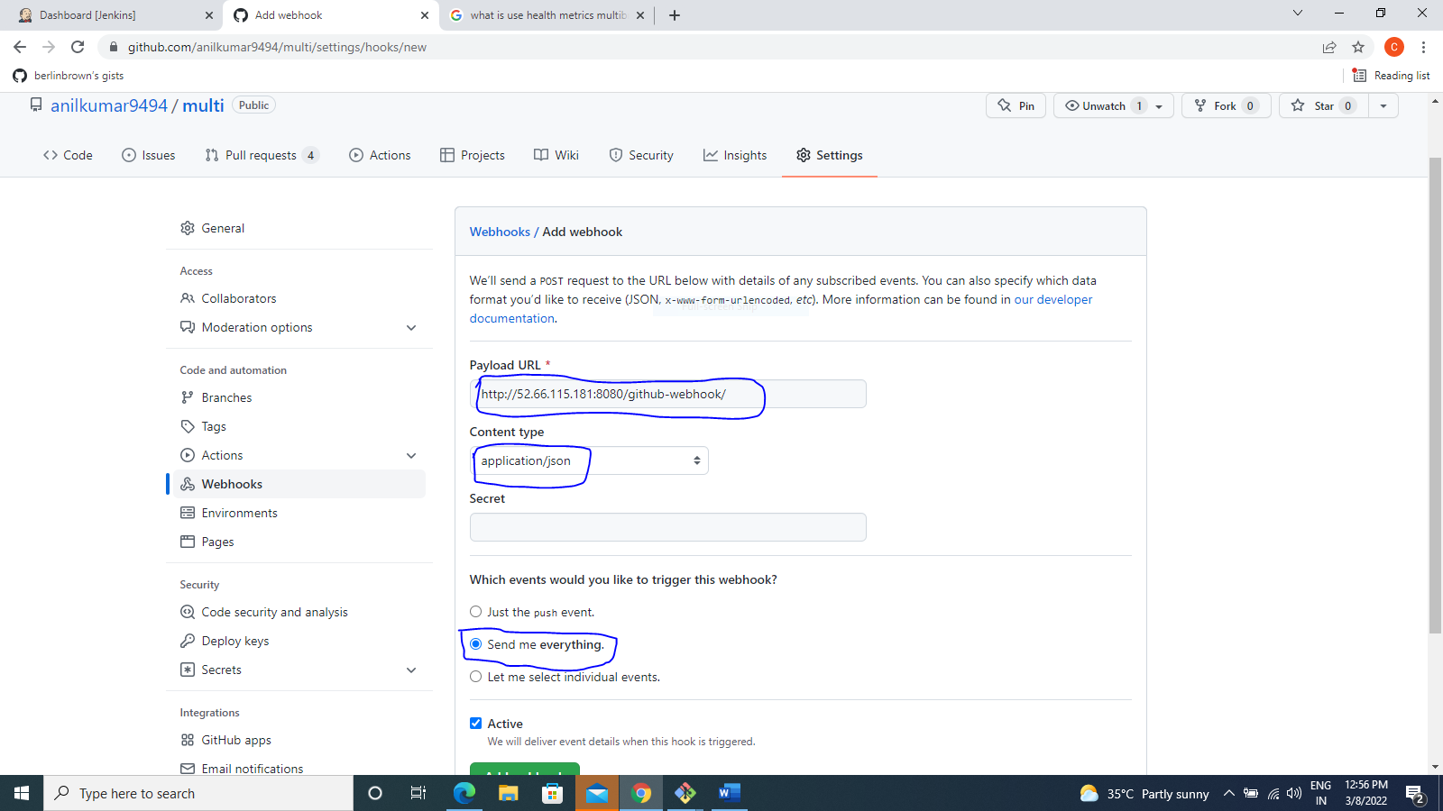

* After show the webhook
* 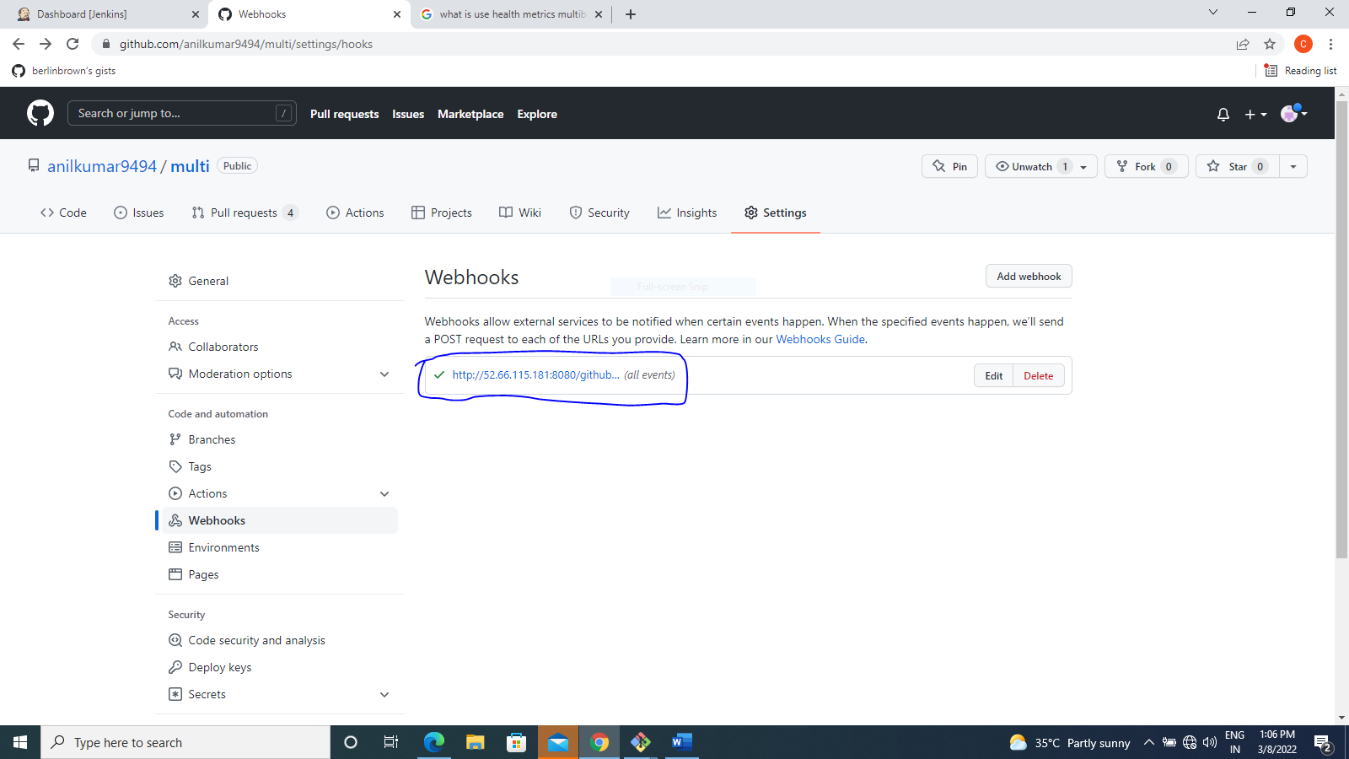
* Go to github click pull request
* Click New pull request

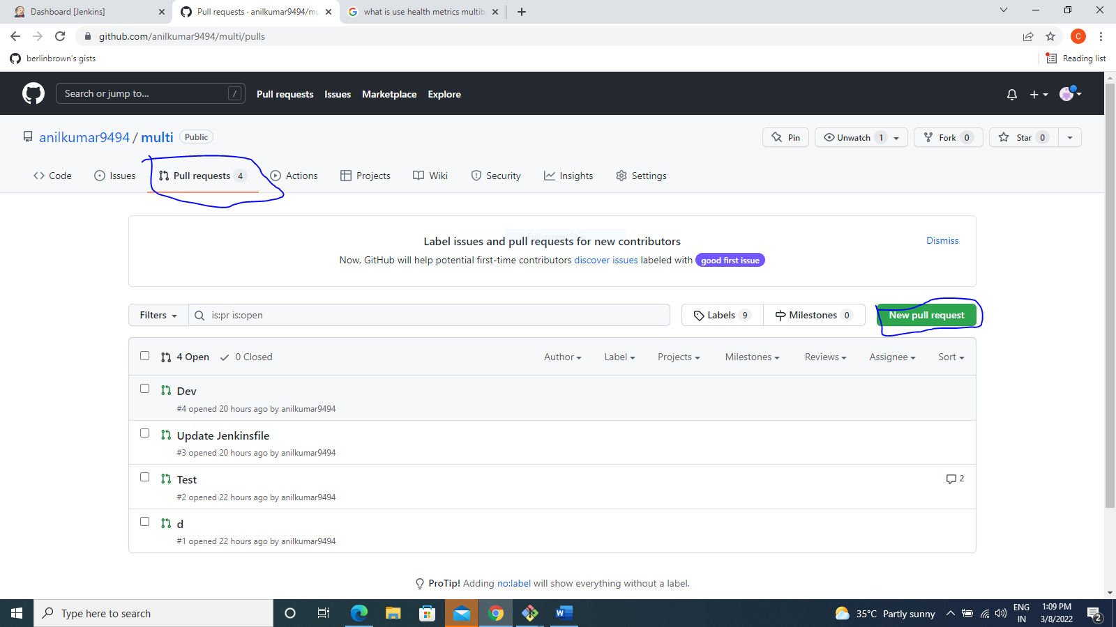

* Base: dev branch
* Click pull request

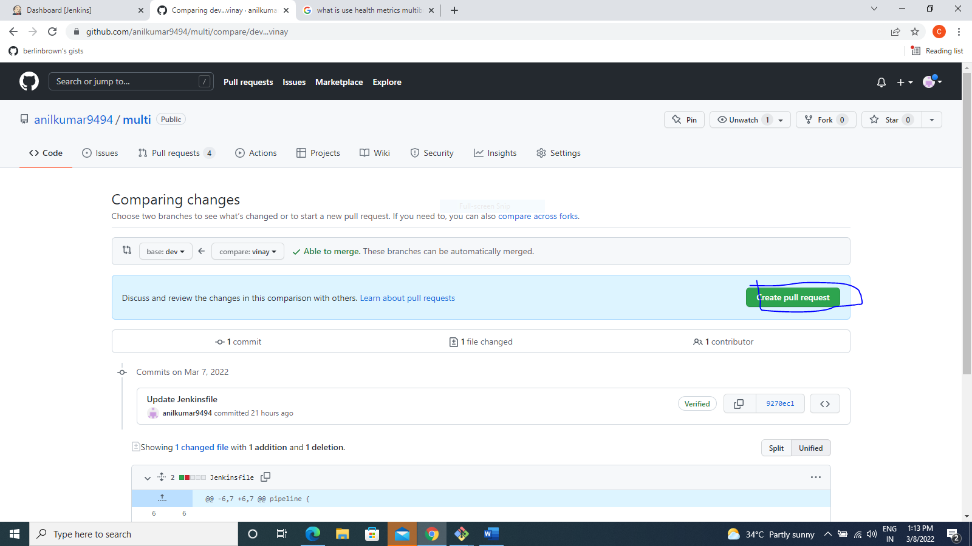

* Write any comment
* Click create pull request

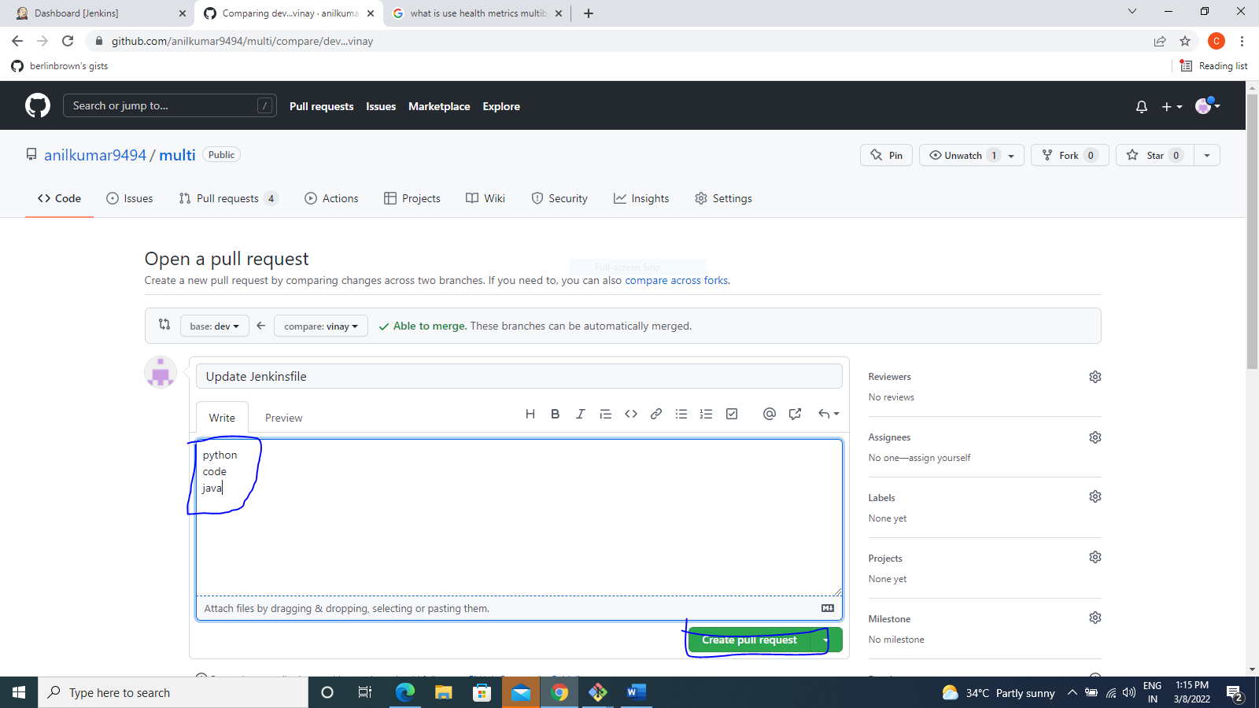

Pull requesting raised

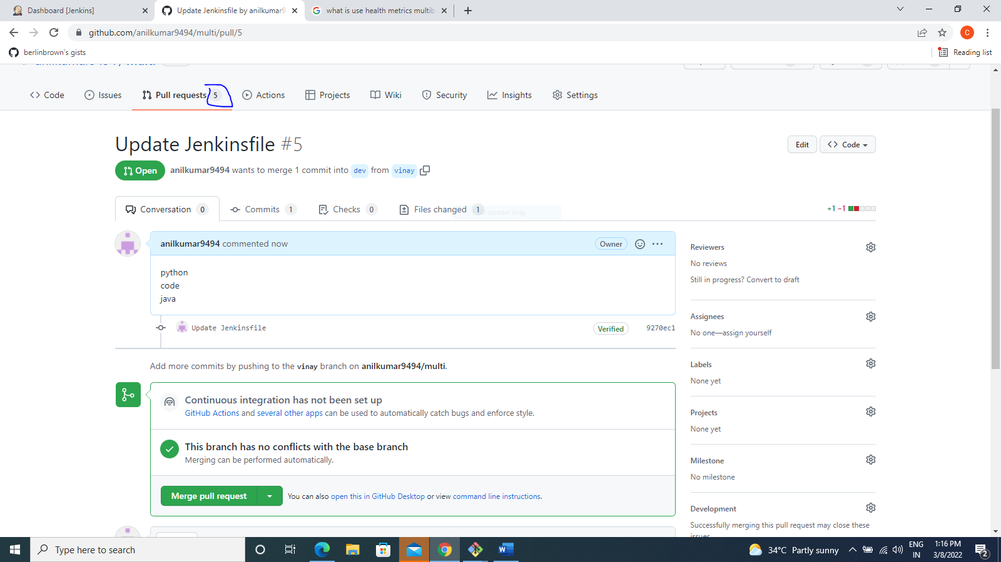

Go to Jenkins job

Automatice traggring and 4 pull request raised

